DCOM Adding Anonymous Login – lowest security you can have.

Start-> Run -> dcomcnfg

Click: Edit Default (Access Permissions)

Hit Find Now:

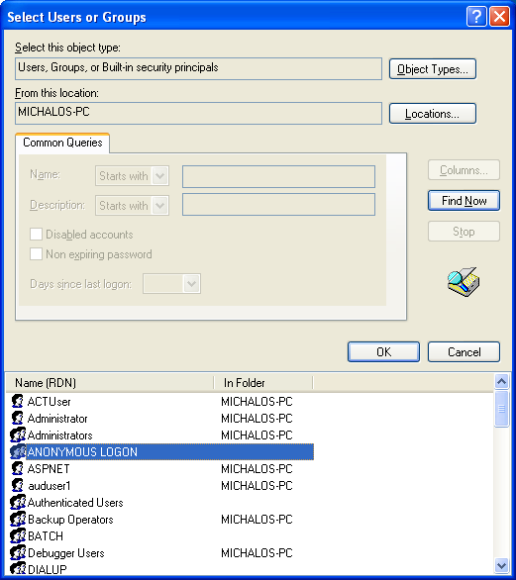
Select ANONYMOUS LOGON Hit OK
1 CLICK OK.
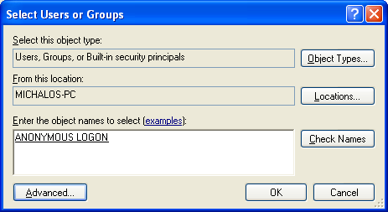

Set ANONYMOUS LOGON Remote Access - Allow

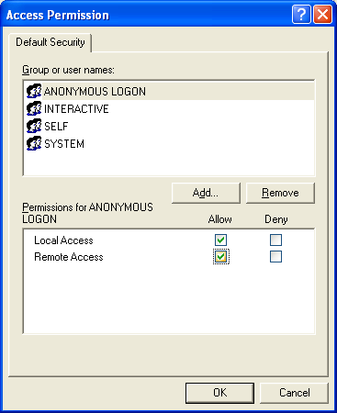

NOW ADD ANONYMOUS LOGONG to Launch and Activation Permission :
